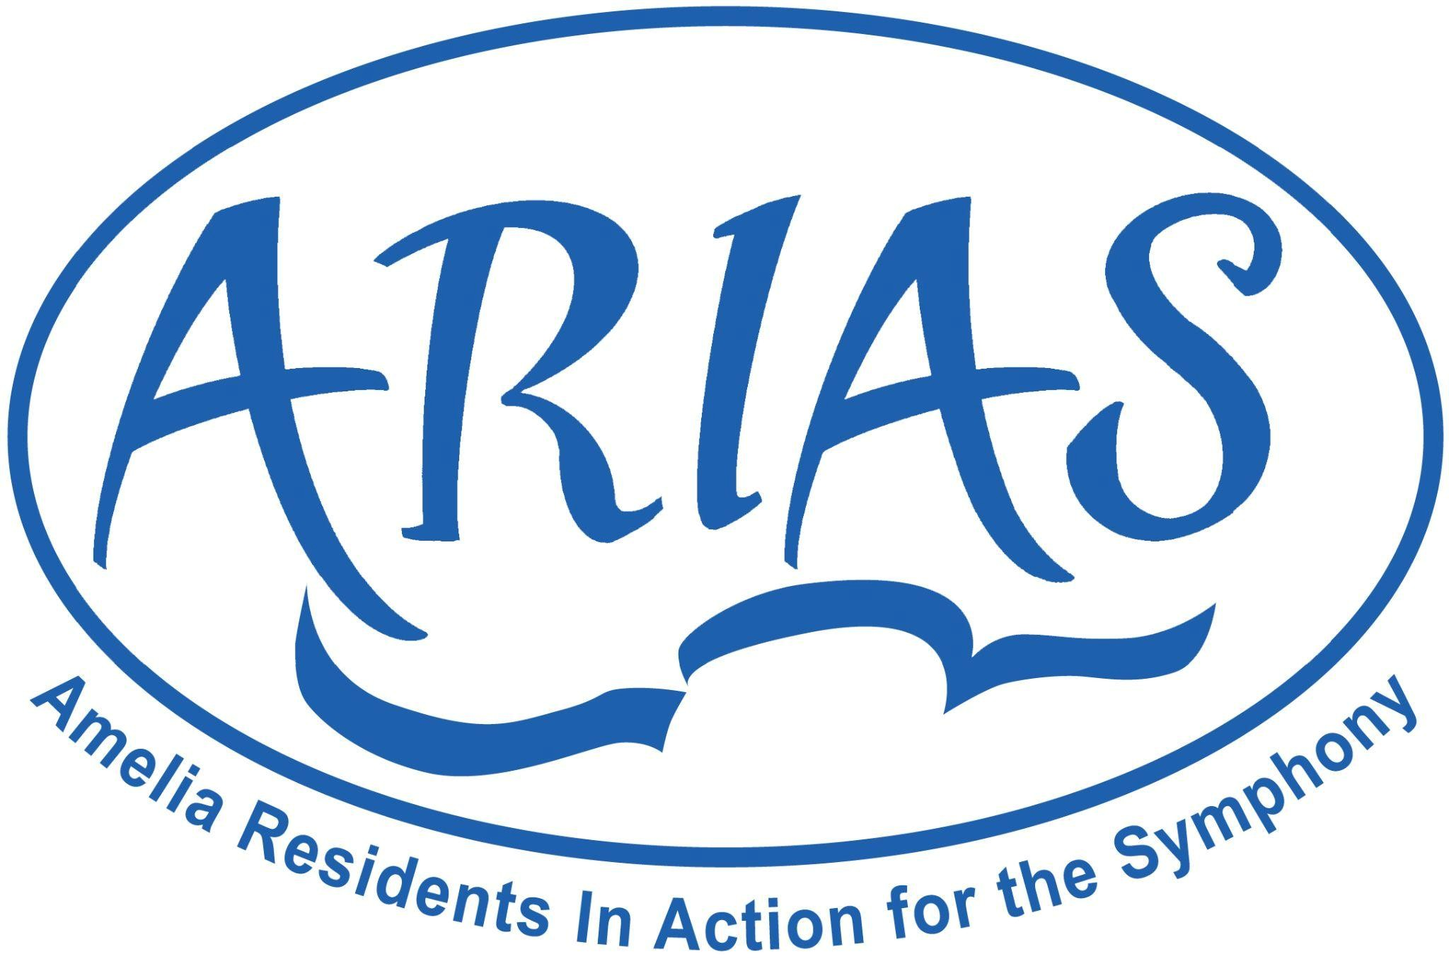

July 2025

Now is the time to become an ARIAS member for this season starting July 2025. ARIAS is committed to enhancing the lives of Nassau County residents with symphonic music and we need your support!

* ARIAS is bringing specialty Jacksonville Symphony Ensembles to Nassau County twice a season.
* ARIAS offers a shuttle bus service from Amelia Island and Yulee to 8 classical music programs in Jacoby Symphony Hall for the Jacksonville Symphony’s 76th Anniversary season.
* ARIAS members will receive discounts on ARIAS sponsored events.
* ARIAS is resuming music education support for over 5,000 Nassau County students. This includes Symphony Ensembles for elementary and middle school performances when possible. A new grant program is again available through an application process. It was implemented in 2025 and offers funds for special middle school music projects.
* ARIAS supports the Jacksonville Symphony through contributions and Board representation.

Thank you! Please invite your friends & neighbors to become ARIAS members too!

To become members until June 2026 you may use our website or please complete this form (next page) and mail a check for $60 (individual) or $100 (couple) and any additional contributions payable to:

**ARIAS, P.O.Box 16203, Fernandina Beach, FL 32035**

**Questions? Contact us ariasnassau@gmail.com**

ARIAS is a 501c3 Charitable organization affiliated with the Jacksonville Symphony. Their mission is to increase awareness of the Jacksonville Symphony in Nassau County, encourage Nassau County resident attendance at Jacoby Symphony Hall and enhance Music Education in Nassau County schools.

Name _______________________________________________________________________________________________ Spouse/Partner ____________________________________________________________________________________ Street:_______________________________________________________________________________________________

City:___________________________________________________ State:_________________ZIP:_________________

Phone:________________________Email(s):____________________________________________________________

Amount Enclosed: $_______________________________________________________________________________